CUSTOMER SUPPORT TICKET PRIORITY
PREDICTION AND AUTOMATED
ASSIGNMENT SYSTEM USING
AGENTFORCE

- – INTRODUCTION
1.1 Introduction
Customer support is an important part of every organization. Customers may contact a company when they face problems related to products, services, accounts or applications.
These customer issues are usually recorded as support tickets. Each ticket contains information such as customer details, issue description, category, status and priority.
When the number of tickets increases, manually processing every ticket becomes difficult. Some important tickets may also be delayed if they are not identified quickly.
To overcome this problem, this project uses Salesforce and Agentforce to support intelligent ticket priority prediction and automated assignment. 1.2 Problem Statement
In a traditional support system, employees manually review customer tickets and decide:
- What is the priority of the ticket?
- Which team should handle the ticket?
- Which support agent should receive the ticket?
- How quickly should the issue be handled?
Manual processing can increase response time and workload.
Therefore, an automated system is required to analyze support tickets, identify their priority and assign them appropriately.
1.3 Objectives
The main objectives of this project are:
- To create a centralized customer support ticket system.
- To capture customer support ticket information.
- To analyze ticket details using Agentforce.
- To identify the priority of support tickets.
- To classify tickets as High, Medium or Low priority.
- To automate ticket assignment.
- To reduce manual effort.
- To improve support team efficiency.
- To provide faster handling of important customer issues.
1.4 Scope of the Project
The project mainly focuses on customer support ticket management.
The system can be used to:
- Create support tickets.
- Store ticket information.
- Analyze ticket details.
- Determine ticket priority.
- Assign tickets to suitable support teams or agents.
- Track ticket status.
- Improve the overall support workflow.

- – EXISTING SYSTEM
  - Existing System
In the existing manual system, customer support employees review incoming tickets individually.
The employee reads the ticket description, determines its importance and manually assigns it to a support agent or department.
  - Limitations
The existing system has several limitations:
    - Manual processing
Each ticket needs to be reviewed manually.
    - Time consumption
Processing a large number of tickets takes more time.
    - Delayed response
Important tickets may not always be identified immediately.
    - Human errors
Incorrect priority or assignment may occur.
    - High workload
Support employees have to spend time on repetitive tasks.
    - Difficulty in handling large volumes
Manual processing becomes difficult when ticket volume increases.

- – PROPOSED SYSTEM
  - Proposed System
The proposed system uses Salesforce and Agentforce to improve customer support ticket management.
When a support ticket is created, its information can be analyzed and the ticket priority can be determined.
The system then supports automated assignment of the ticket to the appropriate support agent or team.

  - Working of the Proposed System The basic workflow is:
Customer Ticket Creation
↓
Ticket Information Stored in Salesforce
↓
Agentforce Analyzes Ticket Details
↓
Priority Prediction
↓
High / Medium / Low Priority
↓
Agent/Team Assignment
↓
Ticket Processing
3.3 Advantages
- Reduces manual work.
- Saves time.
- Improves ticket organization.
- Helps identify important issues.
- Supports faster ticket assignment.
- Improves customer support efficiency.
- Provides centralized ticket management.

- – SYSTEM REQUIREMENTS
  - Hardware Requirements
    - Computer/Laptop
    - Minimum 4 GB RAM
    - Internet connection
    - Keyboard and mouse
  - Software Requirements
    - Operating System: Windows/Linux/macOS
    - Web Browser: Google Chrome / Microsoft Edge
    - Salesforce Platform
    - Agentforce
    - Internet connection
  - Technologies Used
Salesforce
Salesforce is a cloud-based platform used to manage customer information, business processes and customer service operations.

Agentforce
Agentforce provides AI-powered capabilities that can assist users and automate customer service-related tasks.
Salesforce Objects and Fields
Objects and fields are used to store and organize support ticket information.
- – SYSTEM DESIGN
  - System Architecture
The major components of the system are:
Customer
↓
Support Ticket
↓
Salesforce
↓
Agentforce
↓
Priority Prediction
↓
Assignment
↓
Support Agent / Team
5.2 Ticket Processing Flow
- Customer submits a support issue.
- A support ticket is created.
- Ticket details are stored in Salesforce.
- Agentforce processes the available ticket information.
- The ticket priority is identified.
- The ticket is assigned to the appropriate support agent/team.
- The support team handles the issue.
- Ticket status is updated.
5.3 Important Ticket Fields
The support ticket can contain fields such as:
- Ticket Number
- Customer Name
- Customer Email
- Issue Description
- Category
- Priority
- Status
- Assigned Agent
- Support Team
- Created Date
- Resolution Details
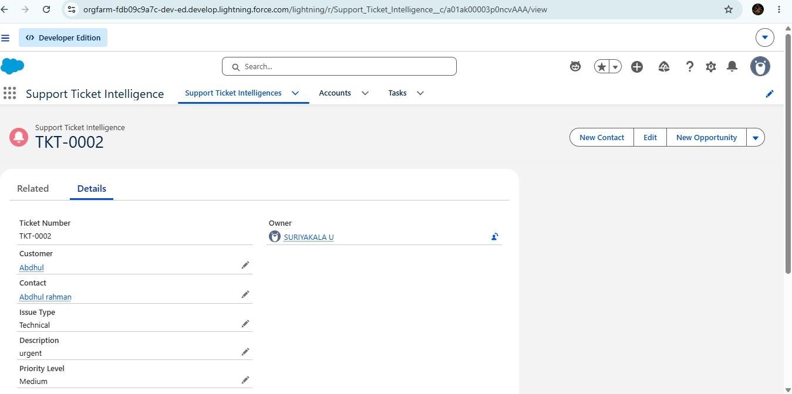

- – SYSTEM IMPLEMENTATION
6.1 Creating the Support Ticket System
A support ticket structure is created in Salesforce to store customer issue information.
The required fields are configured according to the project requirements.
6.2 Creating Ticket Fields
Different fields are created to capture information about the customer issue.
For example:
  - Customer Name
  - Issue Description
  - Category
  - Priority
  - Status
  - Assigned Agent
6.3 Priority Prediction
The ticket information is analyzed to determine the appropriate priority.
The priority can be categorized into:
High Priority
Critical issues that require immediate attention.
Medium Priority
Issues that require attention but are not immediately critical.
Low Priority
General issues that can be handled with lower urgency.
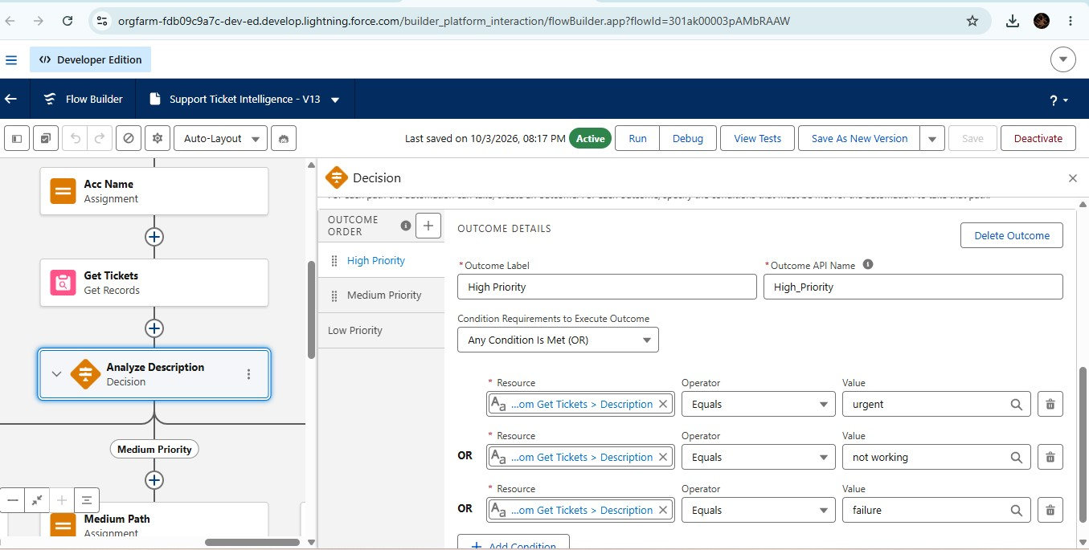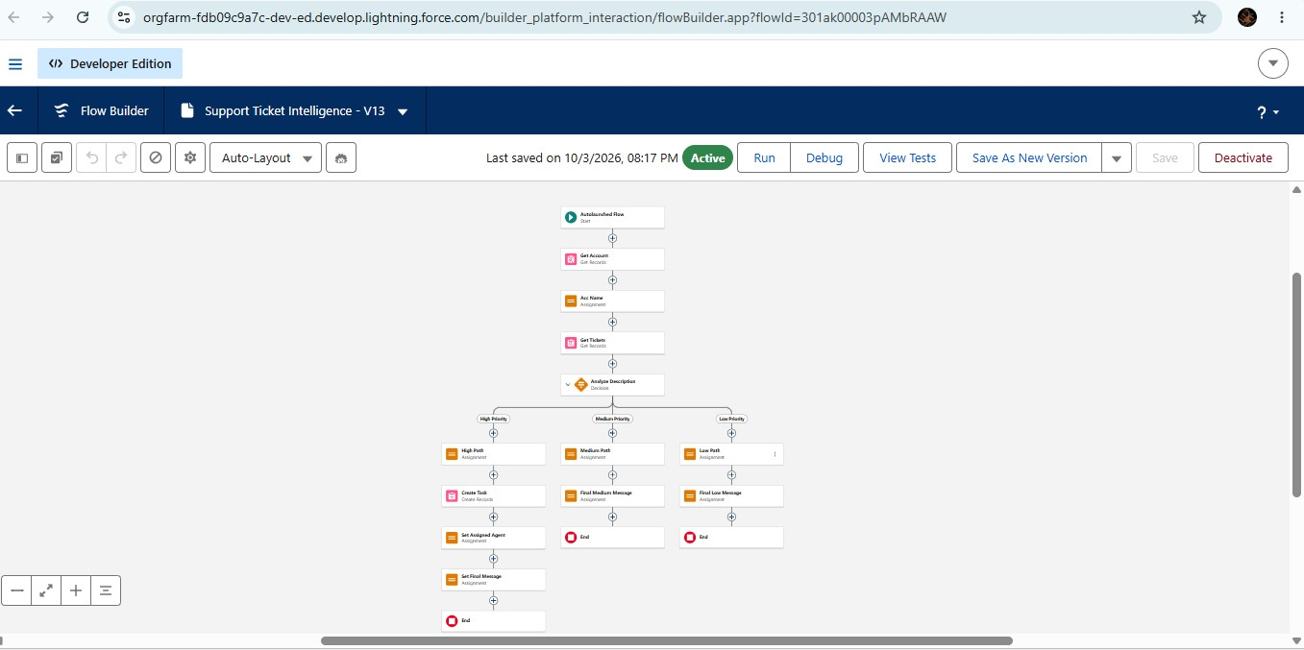

6.4 Automated Assignment
After identifying the ticket priority and relevant information, the system supports assigning the ticket to the appropriate support agent or team.
This reduces the need for manual assignment.

6.5 Agentforce Integration
Agentforce is used as the intelligent support layer of the system.
It can interact with ticket information and assist in:
  - Understanding customer issues.
  - Identifying ticket priority.
  - Supporting ticket assignment.
  - Providing responses or recommendations.
  - Improving support workflow automation.
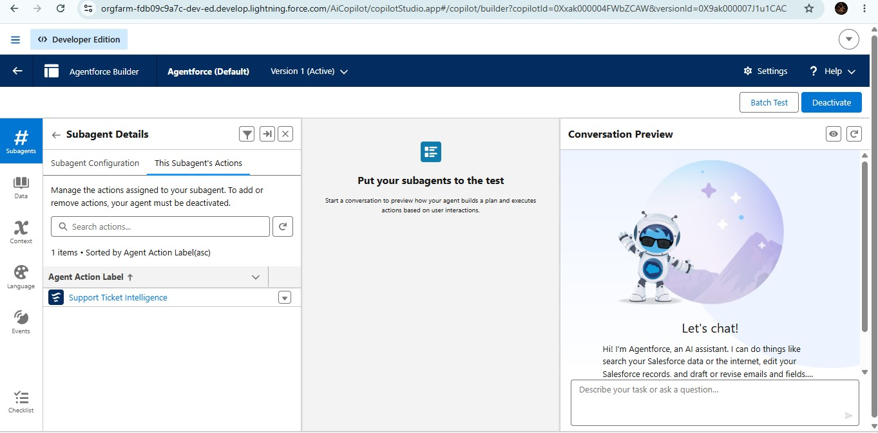
- – TESTING
  - Testing
Testing is performed to verify whether the system behaves as expected.

Test
Case | Input | Expected Result
TC01 | Create support ticket | Ticket should be created
TC02 | Enter issue description | Description should be stored
TC03 | Critical issue | High priority should be identified
TC04 | Normal issue | Medium priority should be identified
TC05 | General issue | Low priority should be identified
TC06 | Process ticket | Appropriate assignment should be supported
TC07 | Update ticket status | Updated status should be displayed
  - Sample Test
Input: Customer reports a critical service issue.
Expected Result:
The system should identify the ticket as a high-priority issue and support assignment to the appropriate support team.
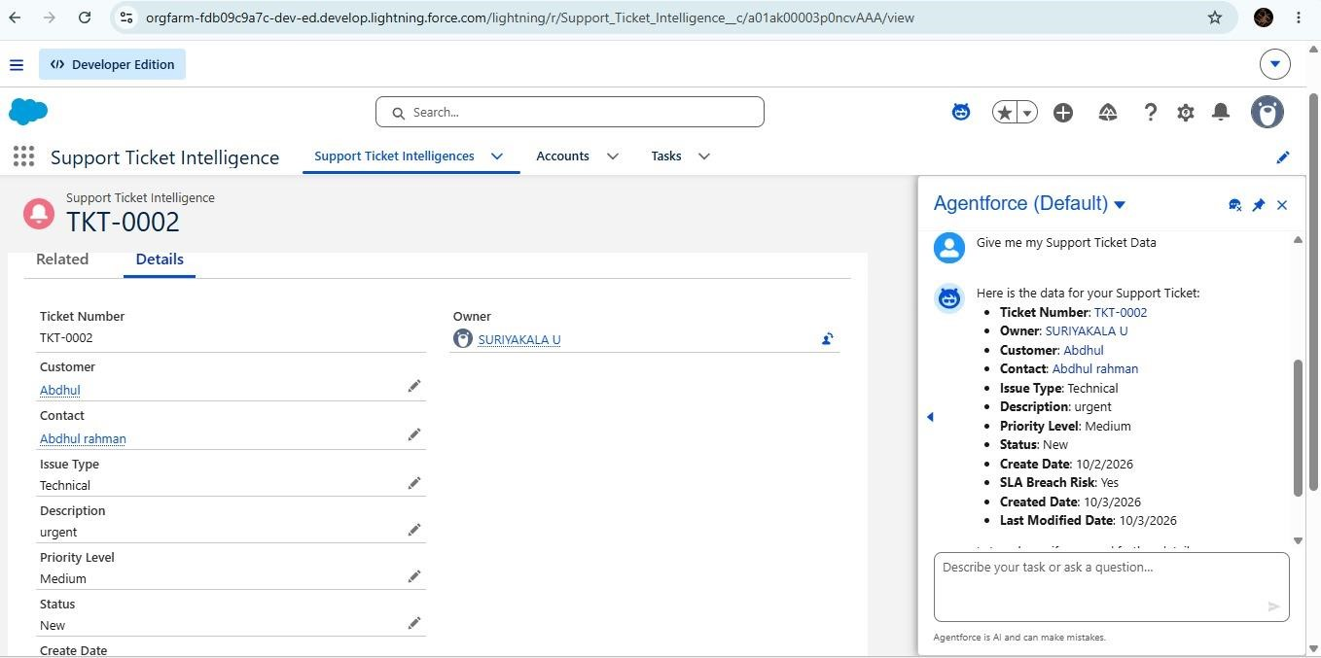

- – RESULTS AND DISCUSSION
The proposed system successfully demonstrates an automated approach to customer support ticket management.
The system provides a structured way to:
    - Create support tickets.
    - Store ticket information.
    - Analyze ticket details.
    - Identify ticket priority.
    - Support automatic assignment.
    - Reduce repetitive manual work.
The use of Agentforce improves the intelligent handling of support ticket information and provides a foundation for further customer service automation.

- – CONCLUSION
The Customer Support Ticket Priority Prediction and Automated Assignment System Using Agentforce provides an efficient approach to managing customer support tickets.
The system helps identify ticket priority and supports automated assignment, reducing manual effort and improving the overall ticket handling process.
By combining Salesforce with Agentforce, organizations can improve the efficiency of their customer support workflow and provide faster attention to important customer issues.

- – FUTURE ENHANCEMENT
The system can be further enhanced with:
    - Advanced AI-based priority prediction.
    - Automatic sentiment analysis of customer messages.
    - Automatic response generation.
    - SLA monitoring.
    - Email and notification integration.
    - Advanced analytics dashboard.
    - Automatic escalation of overdue tickets.
    - Multi-language customer support.
    - Performance monitoring of support agents.

REFERENCES
    - Salesforce Documentation
    - Salesforce Agentforce Documentation
    - Salesforce Trailhead Learning Resources
    - Customer Service Management concepts
    - Artificial Intelligence and Automation concepts

SALESFORCE PROJECT LINK:
https://www.salesforce.com/trailblazer/k1hrmy3nckwvmjchc9

